**West Suffolk to bring back garden waste service on 1 June**

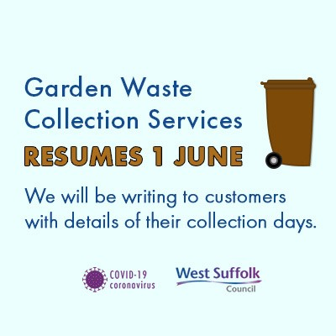

West Suffolk Council will be reintroducing its Garden Waste Collection Service on 1 June after it was stopped due to COVID-19.

The service was paused due to a sudden reduction in staff following the Stay At Home guidance which saw more than 40 waste and street services staff either having to shield themselves as vulnerable or someone in their home.

This remains the case with more than 60 staff redeployed to help the most vulnerable in our communities get support, medicine and food as well as help businesses.

Despite this still being the case the council has worked to reinstate the service in a more robust way so it can cope with any future reduction in staff as well as making rounds efficient to manage the extra growth in the area. This will also include reducing impact on the environment by reducing mileage and fuel use where possible while protecting the safety of residents and staff.

As a result, there may be a change to some collection days and we will be contacting customers direct with details.

Customers have been assured that they will not be out of pocket, with the period of the suspension being added to the current subscription year. This means that their subscriptions will run until 31 May 2021.

Cllr John Griffiths, Leader of West Suffolk Council said: “The pandemic has significantly reduced our own staff and we have had to prioritise services such as the blue and black bin collections while also redeploying over 60 staff to deliver extra support for the vulnerable and our businesses. Despite these challenges continuing,

we will be reintroducing the brown bin garden waste service and  collections from 1 June in a way that is safe for all, robust to cope with future issues and more environmentally friendly. I would like to thank everyone for their patience and understanding and our communities who have shown their appreciation with pictures, gifts and messages of support for our staff, including our bin crews. This has really helped make a very challenging job much easier.”

The West Suffolk Garden Collection Waste Service collects around 12,000 tonnes of garden waste a year, which is composted and returned to the land as soil improver. Customers have been assured that they will not be out of pocket, with the period of the suspension, however long that is, being added to the current year.

Tips for managing garden waste while the service is suspended include home composting with discounts available on equipment and advice both available at Suffolk recycling.

The West Suffolk Garden Waste Collection Service, which last year had 30,000 customers, was suspended on Monday 30 March.

Further information on managing waste at <https://www.westsuffolk.gov.uk/coronavirus>